Task Level (Intermediate):
1. Conduct an in-depth analysis of the Air Quality Index (AQI) in Delhi, addressing the specific environmental challenges faced by the city. Define research questions centered around key pollutants,seasonal variations, and the impact of geographical factors on air quality. Utilize statistical analyses and visualizations to gain insights into the dynamics of AQI in Delhi, offering a comprehensive understanding that can inform targeted strategies for air quality improvement and public health initiatives in the region.
Defining Research Questions :
- Temporal Analysis: How do pollutant levels vary over time (daily, monthly, seasonally)?
- Pollutant Dominance: Which pollutants are most concerning in Delhi?
- Seasonal Patterns: Are there significant seasonal variations in air quality?
- Pollutant Relationships: How do different pollutants correlate with each other?
- AQI Calculation: What is the overall Air Quality Index and its distribution?
- Critical Periods: When does Delhi experience the worst air quality?

Data Loading and Initial Exploration
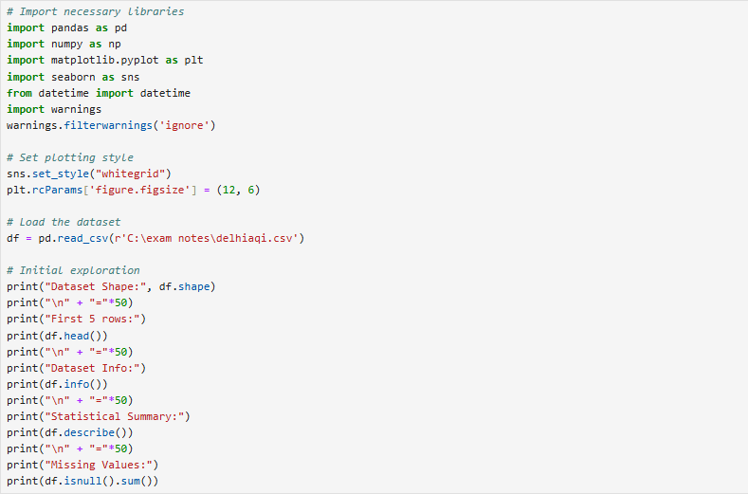
output:
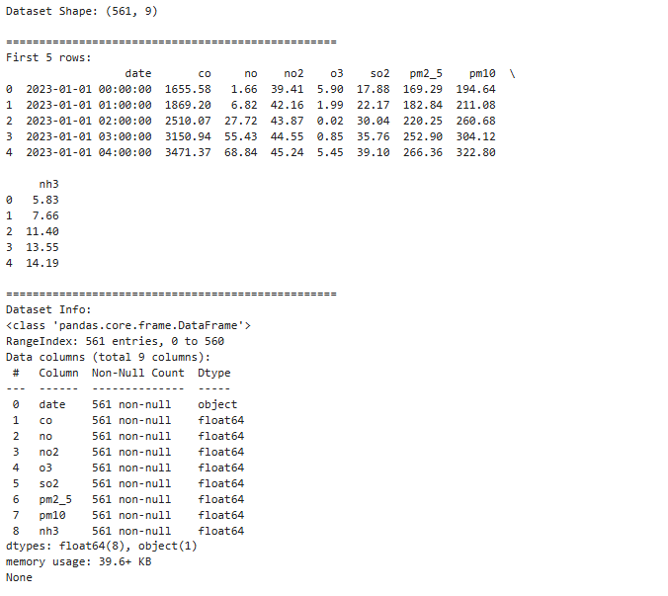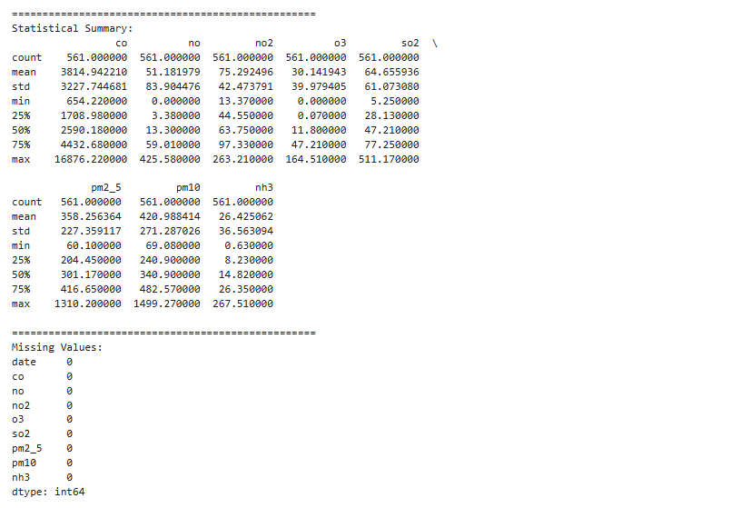
What to look for:
- Data types (ensure date is recognized)
- Missing values (how many and where)
- Range of values for each pollutant
- Any obvious anomalies
Data Cleaning and Preprocessing :

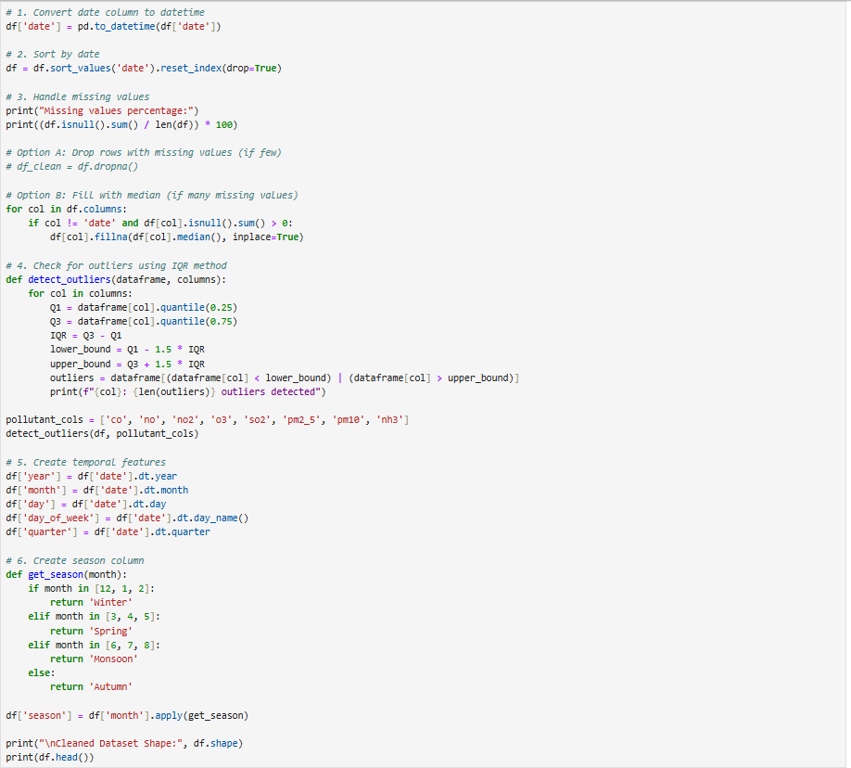

Output:
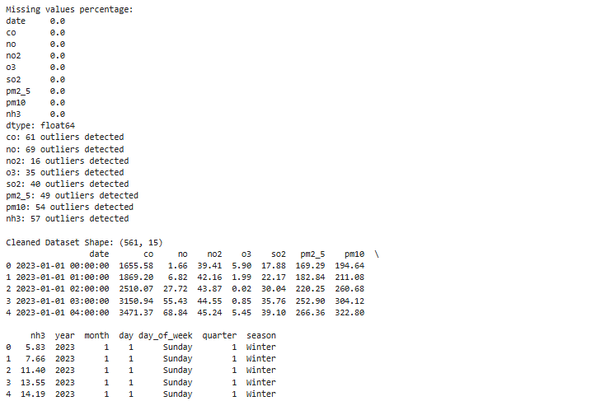
Calculate Air Quality Index (AQI):
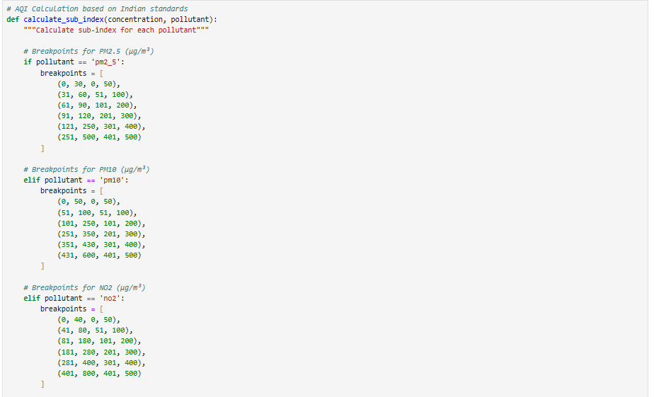

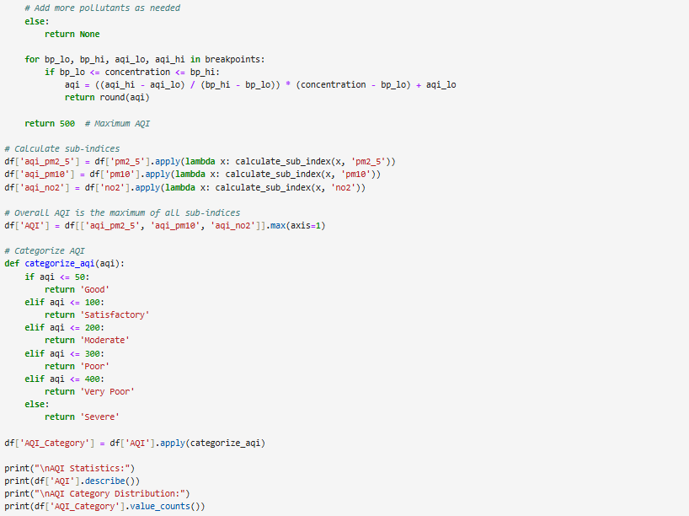
Output:
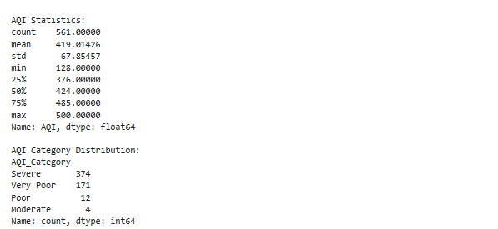

Exploratory Data Analysis (EDA):
1: Temporal Trends Analysis
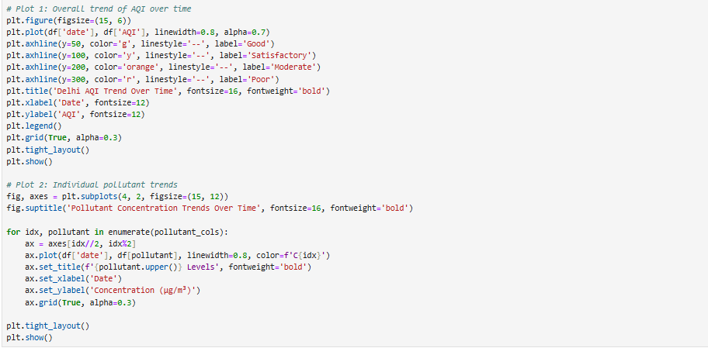
Output:
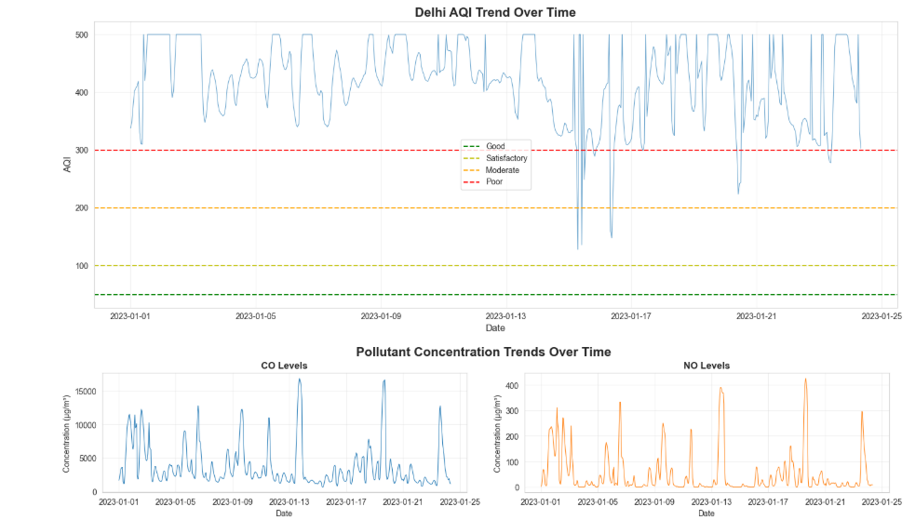
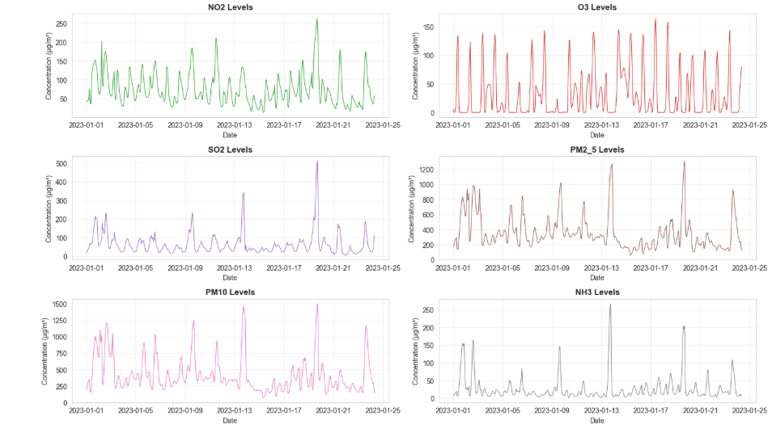

2: Seasonal Analysis
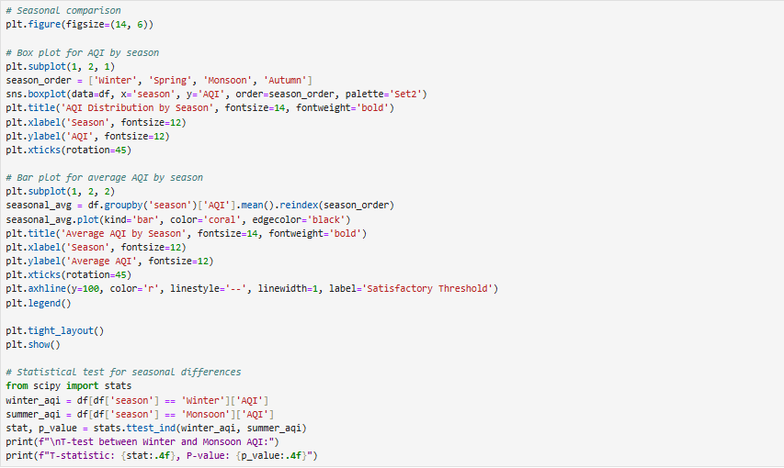

Output:
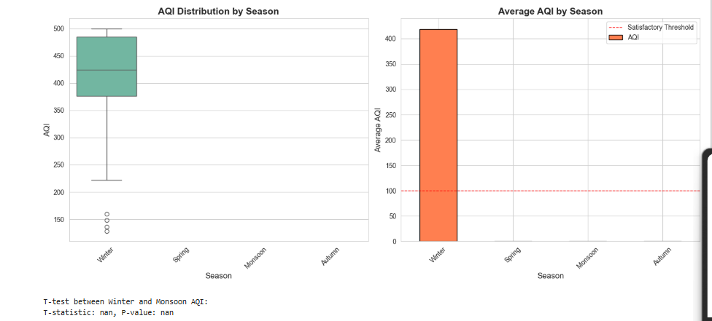
3: Monthly Analysis

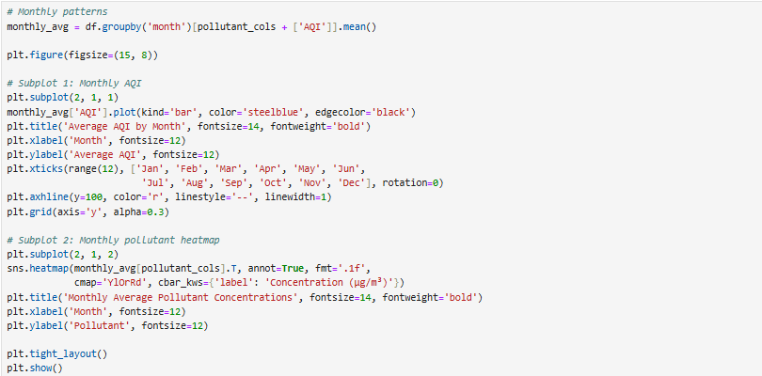

Output:
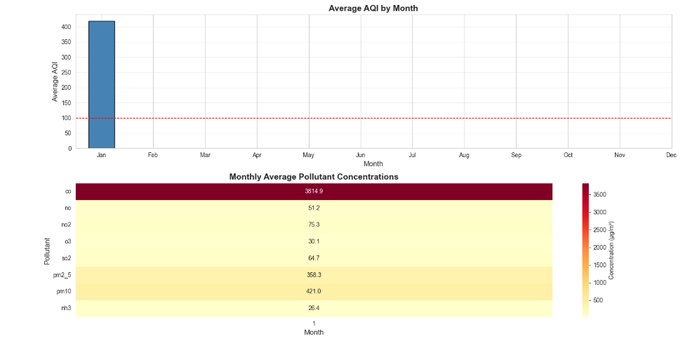

Pollutant-Specific Analysis :

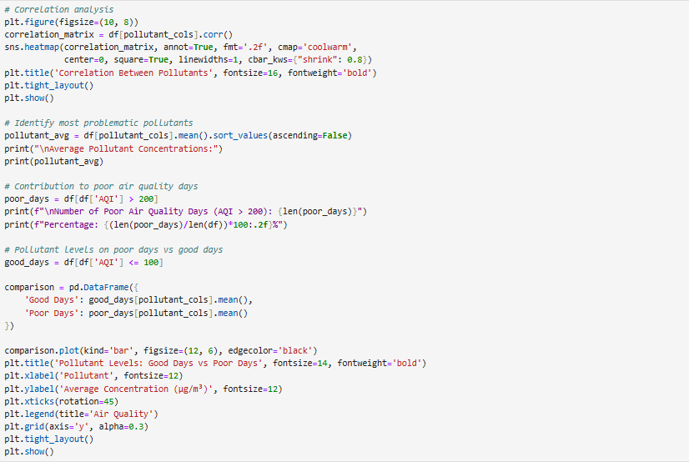

Output:
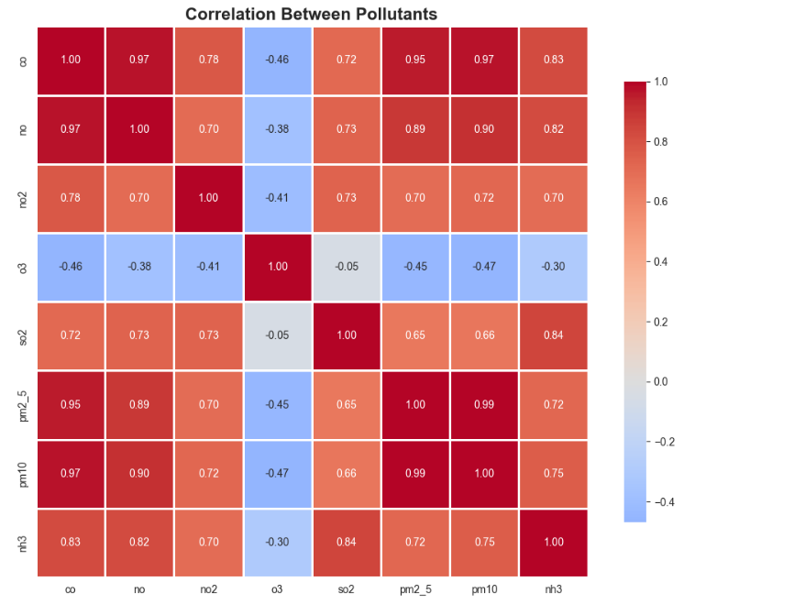
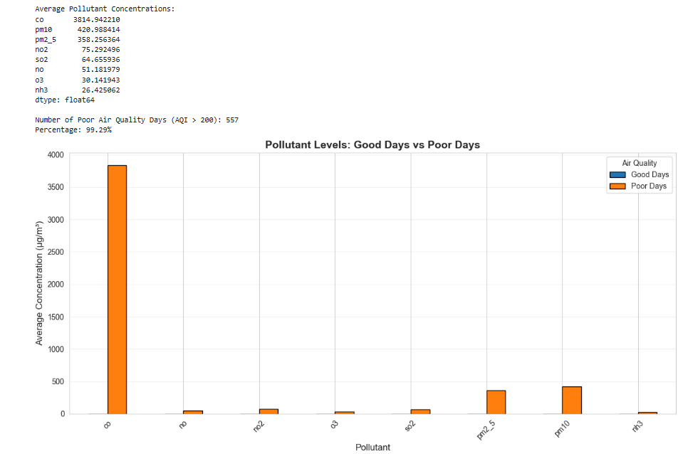
Advanced Statistical Analysis :
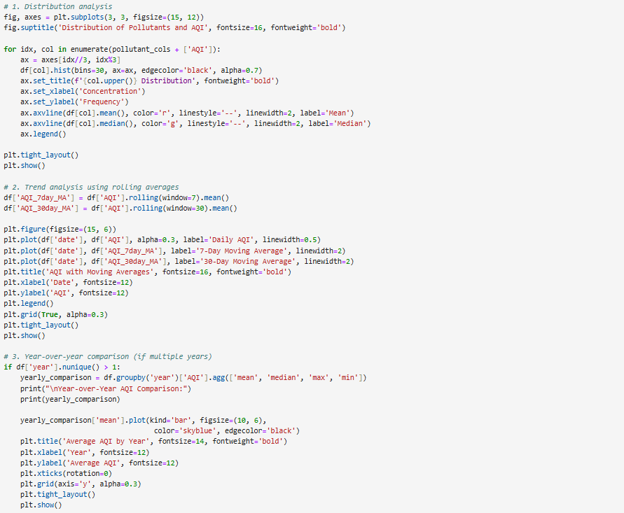
Output:

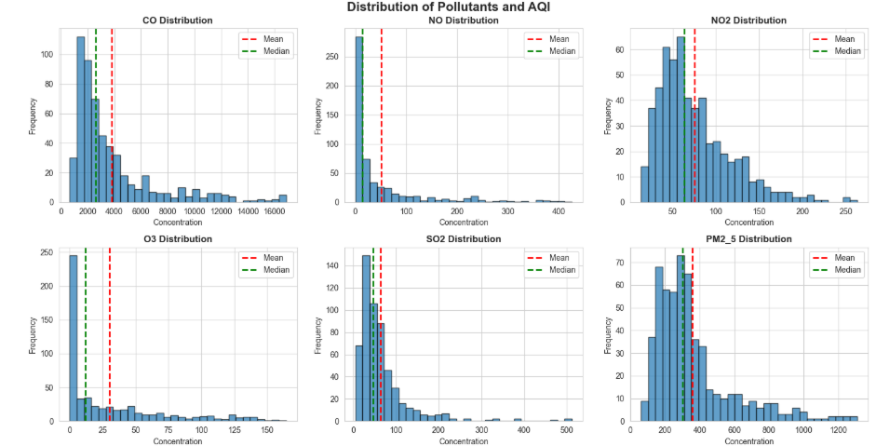
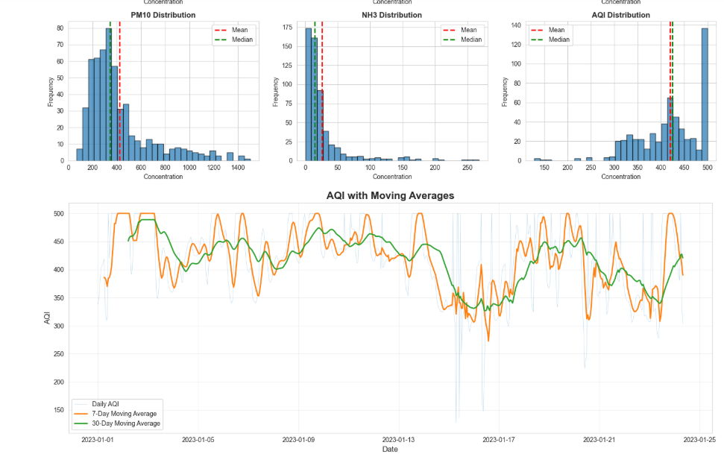

Key Findings and Insights :
